Ideas and suggestions to kickstart your fiction reading

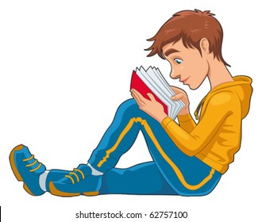

REMS

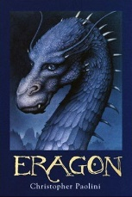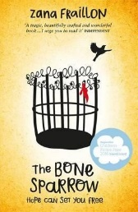**The Boy in the Striped Pyjamas**– John Boyne

**Eragon** – Christopher Paolini

**The Bone Sparrow** – Zana Fraillon

**Divergent** – Veronica Roth

**Roll of Thunder, Hear My Cry**  – Mildred D. Taylor

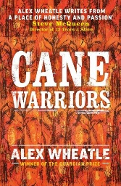**The Hobbit** – J.R.R.Tolkien

**Cane Warriors** – Alex Wheatle

**The Curious Incident of the Dog in the Nighttime** – Mark Haddon

**Journey to Jo’Burg** – Beverley Naidoo

**How I Live Now** – Meg Rosoff

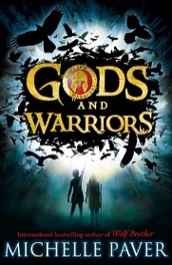

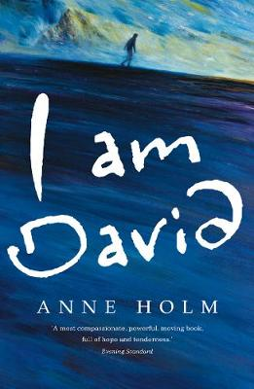**Animal Farm** – George Orwell

**The Maze Runner** – James Dashner

**The FireEaters** – David Almond

**I Am David** – Anne Holm

**Gods and Warriors** – Michelle Paver

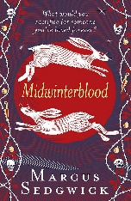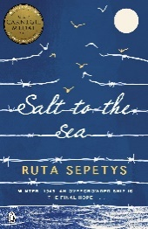

**Salt to the Sea** – Ruta Sepetys

**The Ruby in the Smoke** – Philip Pullman

**Midwinterblood** – Marcus Sedgwick

**My Family and Other Animals** – Gerald Durrell

**Arthur and the Seeing Stone** – Kevin Crossley-Holland

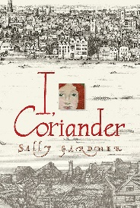**The Amazing Maurice** – Terry Pratchett

**I, Coriander** – Sally Gardner

**The Fault in our Stars** – John Green

**One of Us is Lying** – Karen McManus

**The Secret Diary of Adrian Mole Aged 13 ¾**  – Sue Townsend

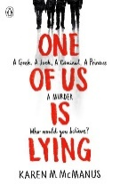

All of these and more available in the school library.